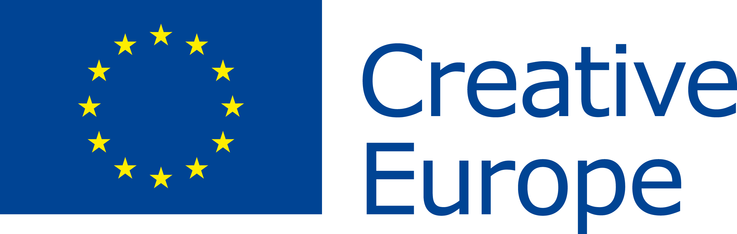 PRESS RELEASE |  |  | 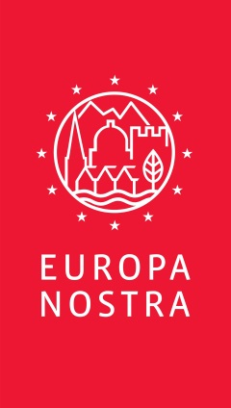
EU Prize for Cultural Heritage / Europa Nostra Award 2017 for
Founder of the Irish National Famine Museum, Jim Callery

Brussels / The Hague, 5 April 2017 - The European Commission and Europa Nostra revealed today the winners of the 2017 European Union Prize for Cultural Heritage / Europa Nostra Awards, Europe’s top honour in the heritage field. The 29 laureates from 18 countries are being recognised for their notable achievements in conservation, research, dedicated service, and education, training and awareness-raising. Mr. Jim Callery, founder of the Irish National Famine Museum & Archive and owner of Strokestown Park, is among this year’s winners in the category dedicated service to heritage. Independent expert juries examined a total of 202 applications, submitted by organisations and individuals from 39 countries across Europe, and chose the winners.

Citizens from around the world can now vote online for the Public Choice Award and rally support for the winning project(s) from their own or another European country. Voters have the chance to win a trip for two to Finland and be a special guest at the Awards Ceremony that will be held in the historic city of Turku on 15 May. During the ceremony, the seven Grand Prix laureates, each of whom will receive €10,000, and the Public Choice Award winner, chosen from among this year’s winning projects, will be announced.

"I congratulate all the winners. Their achievements demonstrate once again how engaged many Europeans are in protecting and safeguarding their cultural heritage. Their projects highlight the significant role of cultural heritage in our lives and our society. Especially today, with Europe facing many big societal challenges, culture is vital in helping us to raise awareness of our common history and values and to foster tolerance, mutual understanding and social inclusion. The European Year of Cultural Heritage in 2018 will be an ideal opportunity to focus on what binds us together as Europeans - our common history, culture and heritage. The European Commission will continue to support this prize and other heritage projects through our Creative Europe programme,” said Tibor Navracsics, European Commissioner for Education, Culture, Youth and Sport.

“I warmly congratulate this year’s winners and pay tribute to all those who made these exceptional achievements possible, thanks to their formidable talent, passionate commitment and great generosity. They are now among a select group of some 450 remarkable accomplishments awarded by Europa Nostra and the European Commission in the past 15 years. All our winners demonstrate that heritage is a key tool for sustainable economic development, social cohesion and a more inclusive Europe. EU leaders should seize the historic opportunity of the European Year of Cultural Heritage in 2018 to recognise the multiple benefits of heritage and its fundamental value in bringing countries, communities and cultures together in Europe and beyond,” stated Plácido Domingo, the renowned opera singer and President of Europa Nostra.

The winners of the EU Prize for Cultural Heritage / Europa Nostra Awards 2017 will be celebrated during a high-profile event co-hosted by EU Commissioner Navracsics and Maestro Plácido Domingo commencing in the late afternoon on 15 May at St. Michael’s Church in Turku. The European Heritage Awards Ceremony will assemble some 1,200 people, including heritage professionals, volunteers and supporters from all over Europe as well as top-level representatives from EU institutions, the host country and other Member States.

The winners will also present their exemplary heritage accomplishments during the Excellence Fair on 14 May at the Sigyn Hall of the Turku Music Conservatory, and participate in various events at the European Heritage Congress in Turku (11-15 May). Organised by Europa Nostra, the Congress will provide an inspiring platform for networking and debating the latest European developments related to heritage with a special focus on the European Year of Cultural Heritage 2018.

Applications for the 2018 edition of the Awards can be submitted from 15 May to 1 October 2017 through the dedicated website.
CONTACTS  Europa Nostra  Joana Pinheiro, jp@europanostra.org, +31 70 302 40 55  Elena Bianchi, eb@europanostra.org, +31 70 302 40 58  European Commission  Nathalie Vandystadt  nathalie.vandystadt@ec.europa.eu, +32 2 2967083  Joseph Waldstein  joseph.waldstein@ec.europa.eu, +32 2 2956184  Mr. Jim Callery  Irish Heritage Trust  Charlotte O'Connor, charlotte@irishheritagetrust.ie  +353 (01) 874 8030, +353 (01) 874 7992 | TO FIND OUT MORE  About each winning project:  information and jury’s comments,  high-resolution photos and videos  Twitter: @europanostra  Creative Europe website  Twitter: @europe_creative  Commissioner Navracsics website  www.irishheritagetrust.ie  www.strokestownpark.ie

2017 Award Winners
(listed alphabetically by country)

Category Conservation
▪ St. Martin’s Chapel in Stari Brod, near Sisak, CROATIA
▪ Baroque Complex and Gardens in Kuks, Hradec Králové region, CZECH REPUBLIC
▪ Ancient city of Karthaia, Island of Kea, GREECE
▪ Bastion of the Grand Master's Palace in Rhodes, GREECE
▪ White Pyramid in Rome, ITALY
▪ The King’s Road across Filefjell, NORWAY
▪ The Clérigos’ Church and Tower in Porto, PORTUGAL
▪ Cultural Palace in Blaj, Transylvania region, ROMANIA
▪ Cap Enderrocat Fortress, Mallorca, SPAIN
▪ Roof for the ruins of the Monastery of San Juan in Burgos, SPAIN
▪ Cromford Mills: Building 17, Derbyshire, UNITED KINGDOM

Category Research
▪ Rode Altarpiece Research and Conservation Project, Tallinn, ESTONIA
▪ ‘Carnival King of Europe’, San Michele all’Adige, ITALY
▪ ‘Museum Piranesi’, Milan, ITALY
▪ Bosch Research and Conservation Project, ‘s-Hertogenbosch, THE NETHERLANDS

Category Dedicated Service
▪ Mr. Ferdinand Meder, Zagreb, CROATIA
▪ Mr. Jim Callery, County Roscommon, IRELAND
▪ The Norwegian Lighthouse Society, NORWAY
▪ Mr. Zoltán Kallós, Transylvania region, ROMANIA

Category Education, Training and Awareness-Raising
▪ Erfgoedplus: Online heritage platform, Hasselt, BELGIUM
▪ Centre of Visual Arts and Research, Nicosia, CYPRUS
▪ Educational programme for Czech cultural heritage, Telc, Vysočina region, CZECH REPUBLIC
▪ Paavo Nurmi Legacy project, Turku, FINLAND
▪ Heritage Crafts Initiative for Georgia, Tbilisi, GEORGIA
▪ Cultural Heritage and Barrier-free Accessibility project, Berlin, GERMANY
▪ ilCartastorie: Storytelling in the archives, Naples, ITALY
▪ Jewish Cultural Heritage: Educational programme, Warsaw, POLAND
▪ Advanced Master in Structural Analysis of Monuments and Historical Constructions, European programme coordinated in Guimarães, PORTUGAL
▪ SAMPHIRE: Maritime heritage project in western Scotland, UNITED KINGDOM

A Europa Nostra Award is also presented to remarkable heritage projects from two European countries not taking part in the EU Creative Europe programme.
Category Conservation: Kılıç Ali Paşa Hamam in Istanbul, TURKEY
Category Research: Philippe Stern’s Collection of Timekeepers, Geneva, SWITZERLAND

Mr. Jim Callery, County Roscommon

In 1959, the year in which Mr. Jim Callery established his motor garage at the gates of Strokestown Park in County Roscommon, he never envisaged that he would come to own and restore the estate on which his ancestors had once been tenants. At its height, the private country estate of Strokestown Park with its extensive Palladian residence was the second largest in Ireland with over 27,000 acres of land being rented out and worked by Irish tenant farmers.

The estate continued to operate on this scale even following the Great Famine of 1845-1852 which resulted in approximately one million Irish deaths caused by starvation and a further population decline of approximately one million due to emigration.

By the time Mr. Callery came to buy the estate in 1979 however, it had shrunk to just 300 acres with the house, ancillary buildings and gardens in a state of complete and advancing decay. The entirety of the contents of the house were later purchased resulting in over 300 years of the family’s history being preserved in the house along with thousands of estate documents which provide an extraordinary perspective on Irish history.

Nearly 40 years on, Mr. Callery has spent millions of his own money, along with help from European Union funds, to restore the house, the gardens, to create a museum to the Irish Famine and an archive of the estate documents which number over 55,000 items.

The restoration and establishment of the world renowned Irish National Famine Museum & Archive by Mr. Callery has been the largest act of private philanthropy for cultural heritage in the history of modern Ireland. The Strokestown estate is now a flourishing hive of activity which provides education, employment and enjoyment for the surrounding region. The Jury greatly appreciated this personal dedication, stating: “Through his small business, Mr. Callery has saved a vital historic country estate for Ireland and has created an important museum and archive dealing with this pivotal moment in the country’s history. He has ensured an expert restoration of the house, opened it to the Irish public and preserved the legacy of this important memorial”.

Background

EU Prize for Cultural Heritage / Europa Nostra Awards

The European Union Prize for Cultural Heritage / Europa Nostra Awards was launched by the European Commission in 2002 and has been run by Europa Nostra since then. It celebrates and promotes best practices related to heritage conservation, research, management, voluntarism, education and communication. In this way, it contributes to a stronger public recognition of cultural heritage as a strategic resource for Europe’s economy and society. The Prize is supported by the Creative Europe programme of the European Union.

In the past 15 years, organisations and individuals from 39 countries have submitted a total of 2,720 applications for the Awards. Concerning the number of entries by country, Spain is first in the ranking, with 498 projects, followed by the United Kingdom, with 286 applications, and Italy, with 278 entries. With regard to the categories, Conservation has had the most submissions (1,606). Next comes Education, Training and Awareness-Raising (457), then Research (340), and, finally, Dedicated Service to Heritage (317).

Since 2002, independent expert juries have selected 455 award-winning projects from 34 countries. In line with the number of entries, Spain tops the list with 61 awards received. The United Kingdom is in second place with 60. Italy comes third (37 awards), Germany fourth (29 awards), and Greece fifth (27 awards). Regarding the categories, Conservation has the most winners (267) followed by Dedicated Service to Heritage (67), Education, Training and Awareness-Raising (65), and, lastly, Research (56).

A total of 95 Grand Prix of €10,000 have been presented to outstanding heritage initiatives, selected from among the award-winning projects.

The EU Prize for Cultural Heritage / Europa Nostra Awards has further strengthened the capacity of the heritage sector in Europe by highlighting best practices, encouraging the cross-border exchange of knowledge and connecting various stakeholders in wider networks. It has also brought major benefits to the winners, such as greater (inter)national exposure, follow-on funding and increased visitor numbers. In addition, it has raised awareness of our shared heritage amongst the general public while highlighting its intrinsic European character. The Prize is therefore a key tool to promote Europe’s heritage.

Europa Nostra

Europa Nostra is the pan-European federation of heritage NGO’s which is also supported by a wide network of public bodies, private companies and individuals. Covering more than 40 countries in Europe, the organisation is the voice of civil society committed to safeguarding and promoting Europe’s cultural and natural heritage. Founded in 1963, it is today recognised as the most representative heritage network in Europe. Plácido Domingo, the world-renowned opera singer and conductor, is the President of the organisation.
Europa Nostra campaigns to save Europe's endangered monuments, sites and landscapes, in particular through ‘The 7 Most Endangered’ programme. It celebrates excellence through the EU Prize for Cultural Heritage / Europa Nostra Awards. It also contributes to the formulation and implementation of European strategies and policies related to heritage, through a structured dialogue with European Institutions and the coordination of the European Heritage Alliance 3.3.

Creative Europe

Creative Europe is the new EU programme to support the cultural and creative sectors, enabling them to increase their contribution to jobs and growth. With a budget of €1.46 billion for 2014-2020, it supports organisations in the fields of heritage, performing arts, fine arts, interdisciplinary arts, publishing, film, TV, music, and video games as well as tens of thousands of artists, cultural and audiovisual professionals. The funding will allow them to operate across Europe, to reach new audiences and to develop the skills required in the digital age.

