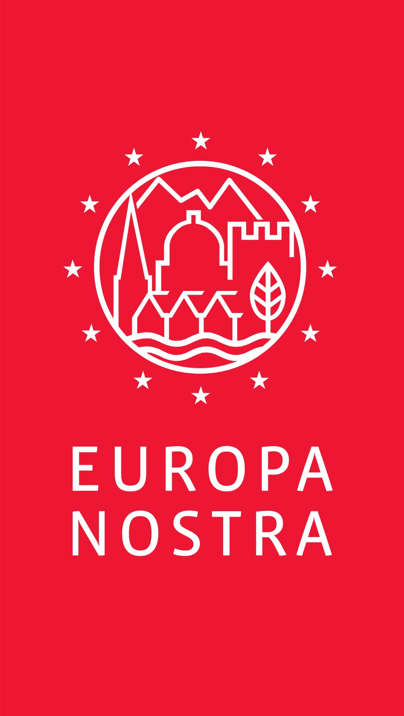

PRESS RELEASE

Europa Nostra calls for Citizens Debates
on the Future of Europe in Heritage Sites

Brussels / The Hague, 9 May 2021 - On the occasion of Europe Day, Europa Nostra – in association with other 50 member organisations of the European Heritage Alliance, which celebrates this year its 10th anniversary – launches a wide call to organise during 2021 inspiring and engaging citizens debates on the future of Europe in cultural heritage sites across Europe. This grassroots initiative is a meaningful contribution both to the Conference on the Future of Europe and to the New European Bauhaus, of which Europa Nostra and some other members of the European Heritage Alliance are proud official partners.

“At the time when Europe and the world are preparing their recovery from the pandemic, let us recall the powerful message released by our European Heritage Alliance, exactly one year ago, on Europe Day 2020: Europe’s shared cultural heritage is a powerful catalyst for the future of Europe. As Europe’s citizens are invited to contribute to the Conference on the Future of Europe, we wish to mobilise Europe’s vast heritage movement and community to take an active part in this citizen-driven process. Let this year’s Europe Day become a renewed call to action for us all!” conveyed Sneška Quaedvlieg-Mihailović, Secretary General of Europa Nostra.

Reacting to this call to action, Dubravka Šuica, Vice-President of the European Commission in charge of Democracy and Demography, who is also Co-Chair of the Executive Board of the Conference on the Future of Europe, shared her support for the initiative: “Europe’s democracies are built on our rich and diverse cultural heritage. Our historical and cultural sites teach us about our common history, remind us of our past dreams and aspirations, of our humanity and creativity. It is all too natural that we debate and discuss our present and future in these magical sites and shape the heritage for Europe’s generations to come.”
Mariya Gabriel, EU Commissioner for Innovation, Research, Culture, Education and Youth, also shared her message of endorsement: “Cultural heritage is at the heart of our EU project. It is Europe’s soul and values. It belongs to all of us and is a great source of unique and creative jobs that show the richness of Europe. I believe that Europa Nostra’s call to mobilize European citizens in inspiring debates on the future of Europe in cultural heritage sites will contribute to our EU initiatives - the Conference on the Future of Europe and the New European Bauhaus -, thus coming up with innovative solutions for building more sustainable, resilient and beautiful future together”.

“For the first time, the European Institutions have launched two major initiatives largely based on the participation of citizens, namely the Conference on the Future of Europe and the New European Bauhaus. We deeply believe that heritage places, both in urban and rural areas, contribute to citizens’ wellbeing and to their sense of belonging and therefore provide ideal settings for imaginative debates on the future of Europe. We are delighted that so many eminent organisations and individuals active in the field of cultural heritage have already committed to contribute (see below),” concluded Jimmy Jamar, Head of Europa Nostra’s Brussels Office.

All citizens and organisations are encouraged to organise a debate in selected heritage sites (including sites that have received a European Heritage Award / Europa Nostra Award or a European Heritage Label) across the European continent, while ensuring full respect of COVID-19 sanitary measures in place. In order to allow the widest participation possible, the initiative remains flexible with regards to the format, scale or duration of the debates. To maximise the impact of these debates, their outcomes will be collected and shared on the relevant platforms of the Europa Nostra Agora, the Conference on the Future of Europe and the New European Bauhaus. Interested partners can find detailed guidelines on how to participate and submit their events via the Europa Nostra Agora digital platform.

We are grateful for the enthusiastic response already received from a large group of heritage champions from all over Europe. We are pleased to share their video messages specially recorded for Europe Day 2021:

- Pilar Bahamonde, President of Future for Religious Heritage, speaking from Potes in Cantabria;
- Lydia Carras, President of Elliniki Etairia, Europa Nostra’s country representation in Greece, speaking from Athens;
- Silvia Costa, Commissioner for the Italian Government for the Restoration of the Santo Stefano prison and former Chair of the European Parliament’s Committee on Culture and Education, speaking from the island of Ventotene;
- Jorge Chaminé, Founder-President of the European Music Centre, speaking from Bougival, near Paris;
- Maka Dvalishvili, Executive Director of the Georgian Arts and Culture Centre, Europa Nostra’s country representation in Georgia, speaking from Tbilisi;
- Bertrand de Feydeau, President of the Fondation des Bernardins, Vice-President of the Fondation du Patrimoine and Vice-President of Europa Nostra, speaking from Paris;
- Luca Jahier, former President of the European Economic and Social Committee, speaking from Turin;
- Uwe Koch, Council member of Europa Nostra, speaking from Potsdam;
- Héctor M. Aliaga de Miguel, European Heritage Youth Ambassador, speaking from Madrid;
- Marshall Marcus, Secretary General of the European Union Youth Orchestra, speaking from London;
- Tapani Mustonen, Architect and Board Member of Europa Nostra, speaking from Turku;
- Alfonso Pallavicini, Executive President of the European Historic Houses Association, speaking from Brussels;
- Catherine Pégard, President of the Public Establishment of the Palace, Museum and National Estate of Versailles who is also President of the European Association of Royal Residences, speaking from Versailles;
- Araceli Pereda Alonso, President of Hispania Nostra, Europa Nostra’s country representation in Spain, speaking from Madrid;
- Robert Quarles van Ufford, President of the Dutch Castles Foundation and Europa Nostra National Coordinator in The Netherlands, speaking from Amersfoort;
- Petr Svoboda, Vice-President of the Association of Castle and Manor Houses Owners, Europa Nostra’s country representation in the Czech Republic, speaking from Prague;
- as well as volunteers from Europa Nostra’s member organisation Touring Club Italiano speaking from Milan.

Europa Nostra is also delighted to pursue its partnership with the European Union Youth Orchestra (EUYO) on the occasion of the Portuguese Presidency of the Council of the European Union to celebrate Europe Day 2021 and the start of the Conference on the Future of Europe with a special online musical performance that will be premiered on 9 May at 11:00 CET on the EUYO YouTube channel. Under the theme “Time to deliver: What can the Arts do to help Europe’s Recovery?”, these performances were recorded by EUYO musicians in two of Europe’s most culturally and historically significant palaces: the Mafra National Palace in Portugal, which was inscribed on the UNESCO World Heritage List in 2020, and the Palais Lichtenau in Potsdam, Germany, a major historic building of early classicism.
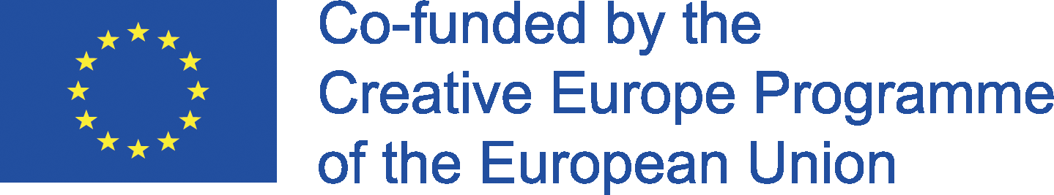
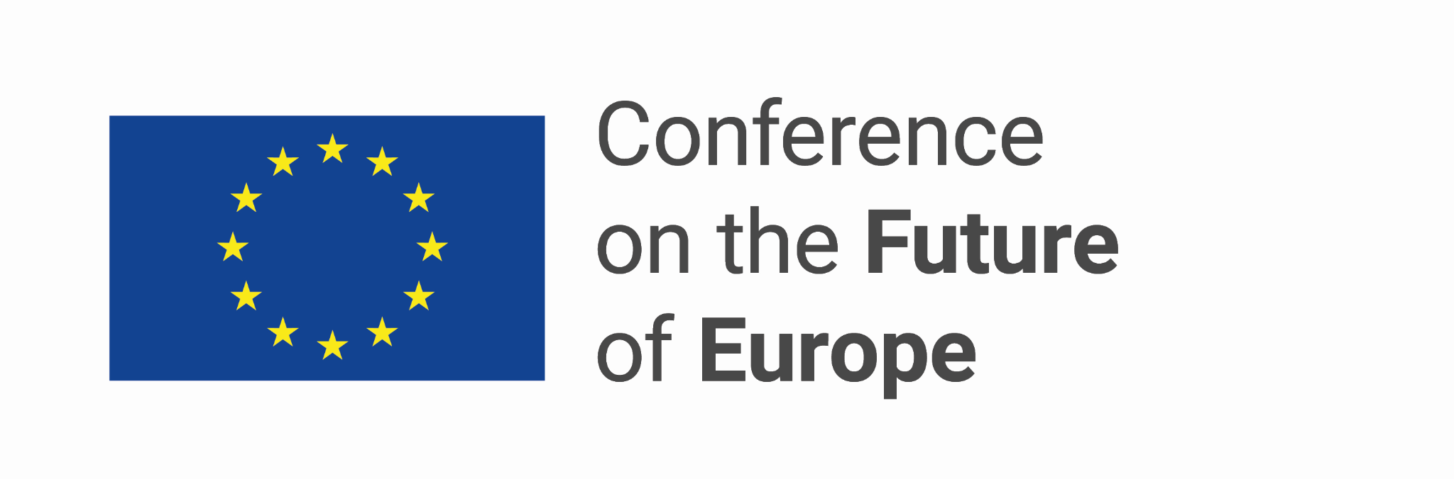
CONTACTS  Europa Nostra Brussels Office  Jimmy Jamar, Head of Office  jimmy.jamar52@gmail.com,  T. +32 (0) 2486 25 26; M. +32(0)498980045  Manon Richard, EU Projects Officer  mr@europanostra.org,  T. +32(0)24862526; M. +33(0)785587527 | TO FIND OUT MORE  europanostra.org  europanostra.org/agora/  europeanheritagealliance.eu  Download visuals  Download videos

BACKGROUND INFORMATION
Europa Nostra
Europa Nostra is the European voice of civil society committed to safeguarding and promoting cultural and natural heritage. A pan-European federation of heritage NGOs, supported by a wide network of public bodies, private companies and individuals, it covers more than 40 countries. Founded in 1963, it is today recognised as the largest and the most representative heritage network in Europe. Europa Nostra campaigns to save Europe’s endangered monuments, sites and landscapes, in particular through the 7 Most Endangered Programme. Europa Nostra actively contributes to the definition and implementation of European strategies and policies related to heritage, through a participatory dialogue with European Institutions and the coordination of the European Heritage Alliance. Europa Nostra was the EU's key civil society partner during the European Year of Cultural Heritage in 2018. It also figures among the first official partners of the New European Bauhaus initiative recently launched by the European Commission.
European Heritage Alliance
The European Heritage Alliance is an informal platform bringing together 50 European and international networks active in the wider heritage field. The European Heritage Alliance members represent a very large constituency composed of tens of millions of Europe‟s citizens. Since its launch in June 2011, the coordination of the Alliance has been ensured by Europa Nostra.

European Union Youth Orchestra
The European Union Youth Orchestra (EUYO) is one of the world’s pre-eminent symphony orchestras, which has provided an exceptional bridge between music colleges and the professional music world for generations of Europe’s finest musicians. Founded by Joy and Lionel Bryer in 1976, the EUYO has been a Cultural Ambassador for the European Union for more than forty years. The EUYO’s Honorary President is David Sassoli, President of the European Parliament, and its Honorary Patrons include Ursula von der Leyen, President of the EU Commission and Charles Michel, President of the European Council, as well as the Heads of State and Government, the ministers of foreign affairs and culture of the EU member states.

Conference on the Future of Europe
The Conference on the Future of Europe is a unique and timely opportunity for European citizens to debate on Europe’s challenges and priorities. Everybody can contribute to the debate via the multilingual digital platform or by organising decentralised events. The European Parliament, the Council and the European Commission have committed to listen to Europeans and to follow up, within their sphere of competences, on the recommendations made. By spring 2022, the Conference is expected to reach conclusions and provide guidance on the future of Europe.

New European Bauhaus
Launched by the President of the European Commission Ursula von der Leyen in September 2020, the New European Bauhaus aims at bringing the European Green Deal closer to citizens and their living spaces by bridging the world of science and technology with the world of art and culture. This creative and interdisciplinary movement shall gather designers, architects, engineers, scientists, students and creative minds across disciplines to imagine our collective future around the core values of sustainability, aesthetics and inclusiveness. Everybody can take part in the co-design phase of the New European Bauhaus by organising debates or sharing inspiring projects and publications.

Creative Europe
Creative Europe is the EU programme that supports the cultural and creative sectors, enabling them to increase their contribution to jobs and growth. With a budget of €1.64 billion for 2021-2027, it supports organisations in the fields of heritage, performing arts, fine arts, interdisciplinary arts, publishing, film, TV, music, and video games as well as tens of thousands of artists, cultural and audiovisual professionals.

