CLIMATE HERITAGE NETWORK
General Assembly, COP 26, 1 November 2021

Dear Andrew, Dear Ewan,
Dear Colleagues,

On behalf of Europa Nostra - the European Voice of Civil Society committed to Cultural Heritage, also coordinator of the European Heritage Alliance and a proud founding member of the Climate Heritage Network - I wish to thank you for your confidence and I wish to confirm that we accept the challenging task to become the next regional Co-chair of the Climate Heritage Network covering Europe and the Commonwealth of Independent States.

Europa Nostra has a vast and relevant experience in managing membership, partnership and advocacy networks in the cultural heritage field and the wider world of culture. As such we were particularly active before, during and after the ground-breaking European Year of Cultural Heritage in 2018 which helped articulate better the relationship between place, people and environmental sustainability. Today, we are keen to use this pan-European experience and network for the benefit of the Climate Heritage Network.

Thanks to the vast knowledge and drive of Andrew Potts, Europa Nostra partnered with ICOMOS, the Climate Heritage Network and the European Investment Bank Institute to produce earlier this year the European Cultural Heritage Green Paper . This paper scoped the ways cultural heritage can contribute to achieving the ambitions of the European Green Deal in areas like renovation of the buildings, mobility, circular economy, energy, food and agriculture. This paper, together with our recent “Venice Call to Action: For a New European Renaissance”, reflect our ever-growing engagement with issues of cultural heritage and climate action, in Europe and globally.

To end, let me pay tribute to the pioneering role played by all of you who have been leading and contributing to the Climate Heritage Network during the first two years of its existence. We have learnt so much and we continue to learn from all of you. Today, as we are about to take over from Historic Environment Scotland (HES) the role of regional Co-Chair, we are aware of the huge responsibility ahead of us. With your commitment and advice, we shall do our utmost to live up to your expectations.

Dear Colleagues,

let us continue to join our voices and forces across continents to truly unleash the great potential of culture and cultural heritage for an effective climate action, as our contribution to the “race to resilience”, here at the COP 26 and beyond!

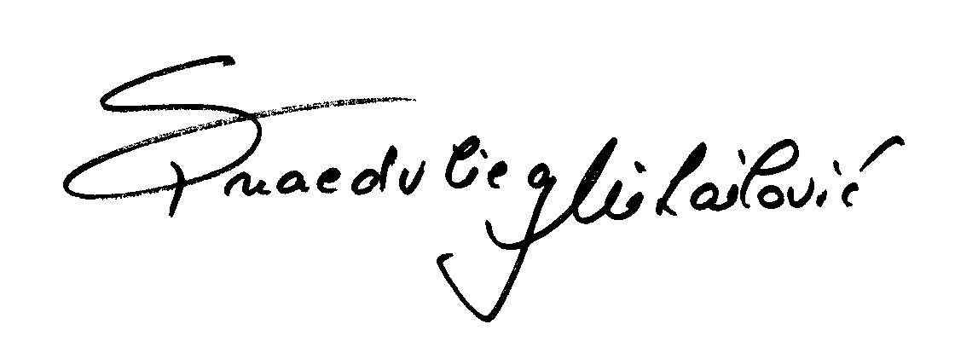

Sneška Quaedvlieg-Mihailović
Secretary General

