 | 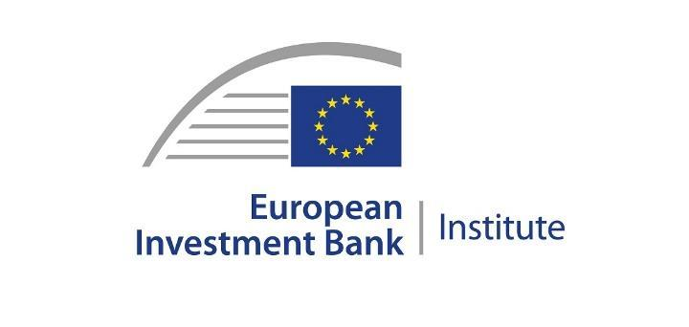 | 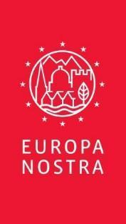

PRESS RELEASE

European experts’ report highlights the
urgent need to save and rehabilitate Zogu’s Bridge in Albania

The Hague / Brussels, 3 April 2023

In a technical report issued today, experts from Europa Nostra and the European Investment Bank Institute highlight the urgent need to stabilise and rehabilitate Zogu’s Bridge in Albania, listed among the 7 Most Endangered heritage sites in Europe for 2022.

“This is a worthwhile and challenging rehabilitation project which needs to be implemented urgently to save the emblematic Zogu’s Bridge from collapse. Recent arrangements and proposals to achieve this have so far been sound, but major challenges remain both to define and then to complete the works on time. These efforts should extend in due course beyond the immediate preventive measures to a complete rehabilitation of the bridge to allow safe and appropriate use of the bridge, thereby enhancing its industrial heritage and scenic value. The centenary of the opening of the bridge is in 2027 and this could be a suitable target for its full rehabilitation”, the report emphasises.

Zogu’s Bridge is an exceptional structure of national and international importance. It crosses the Mat River and was opened in 1927 with six bowstring arches in reinforced concrete of innovative design. It now comprises five arches as the northern span was destroyed at the end of World War II. The bridge has degraded badly since it was excluded from the national road network in 1978 being unsuitable for modern traffic. In 1999 the bridge was recognised as a National Monument and ownership was transferred from the Directorate of Road Authority to the Institute of Cultural Heritage in the Ministry of Culture.

Zogu’s Bridge was nominated to the 7 Most Endangered Programme 2022 by Emarilda Leti, Head of the local NGO Sebastia based in Luc, with the support of Professor Lida Miraj, representative of Europa Nostra in Albania.

Zogu’s Bridge was in poor shape when it was included on the list of 7 Most Endangered in March 2022; but its condition got dramatically worse following a large flood in November 2022, when a pier supporting the bridge settled much further, creating a serious risk of collapse. Both facts helped to accelerate the authorities’ response and serious efforts are now being made to save the bridge from collapse and then to rehabilitate it. This process is at an early stage and several technical and other problems have been identified in the report.

The report was formulated on the basis of the outcomes of the expert mission in Albania undertaken between 6 and 11 February 2023. During the mission, Pedro Ponce de Leon, Architect and Council Member of Europa Nostra, and Peter Bond, Technical Consultant provided by the EIB Institute, visited Zogu’s Bridge and had meetings with the main stakeholders, including from the Ministry of Culture, the Technical Team from University Polytechnic of Tirana, the Albanian Association of Consulting Engineers, the Directorate of Albanian Road Authority and the Association Sebastia.

PRESS CONTACTS  EUROPA NOSTRA  Joana Pinheiro  Communications Coordinator  E. jp@europanostra.org, M. +31 6 34 36 59 85  ASSOCIATION SEBASTIA  Emarilda Leti, E. sebastia_ojf@outlook.com  M. +355697820521 | MORE INFORMATION  Technical Report (PDF)  Photos of the mission (high resolution)  www.7mostendangered.eu  www.europanostra.org  www.facebook.com/sebastia.kurbin
Background information

The 7 Most Endangered Programme

The 7 Most Endangered Programme, which celebrates its 10th anniversary this year, is run by Europa Nostra in partnership with the European Investment Bank Institute. It also has the support of the Creative Europe programme of the European Union. Launched in 2013, the programme forms part of a civil society campaign to save Europe's endangered heritage. It raises awareness, prepares independent assessments and proposes recommendations for action. It also provides a grant of €10,000 per listed site to assist in implementing an agreed activity that will contribute to saving the threatened site. In most cases, the listing of an endangered site serves as a catalyst and incentive for the mobilisation of necessary public or private support, including funding.

Europa Nostra

Europa Nostra is the European voice of civil society committed to safeguarding and promoting cultural and natural heritage. It is a pan-European federation of heritage NGOs, supported by a wide network of public bodies, private companies and individuals, covering over 40 countries. It is recognised as the largest and the most representative heritage network in Europe, maintaining close relations with the European Union, the Council of Europe, UNESCO and other international bodies. Founded in 1963, Europa Nostra celebrates its 60th anniversary this year.
Europa Nostra campaigns to save Europe’s endangered monuments, sites and landscapes, in particular through the 7 Most Endangered Programme. It celebrates excellence through the European Heritage Awards / Europa Nostra Awards. Europa Nostra actively contributes to the definition and implementation of European strategies and policies related to heritage, through a participatory dialogue with European Institutions and the coordination of the European Heritage Alliance.
Europa Nostra is among the official partners of the New European Bauhaus initiative developed by the European Commission, and is the Regional Co-Chair of the Climate Heritage Network for Europe and the Commonwealth of Independent States.

European Investment Bank Institute

The European Investment Bank Institute (EIB-I) was set up within the EIB Group (European Investment Bank and European Investment Fund) to promote and support social, cultural, and academic initiatives with European stakeholders and the public at large. It is a key pillar of the EIB Group’s community and citizenship engagement. More information at http://institute.eib.org

Creative Europe

Creative Europe is the EU programme that supports the cultural and creative sectors, enabling them to increase their contribution to Europe’s society, economy and living environment. With a budget of €2.4 billion for 2021-2027, it supports organisations in the fields of heritage, performing arts, fine arts, interdisciplinary arts, publishing, film, TV, music, and video games as well as tens of thousands of artists, cultural and audiovisual professionals.

