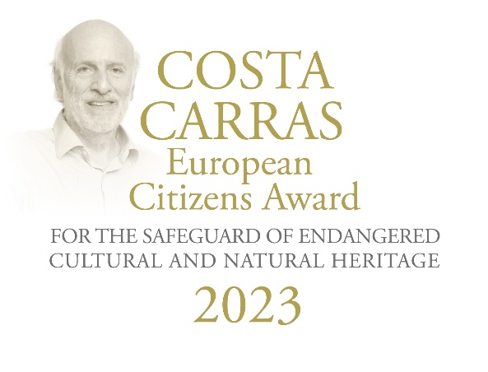
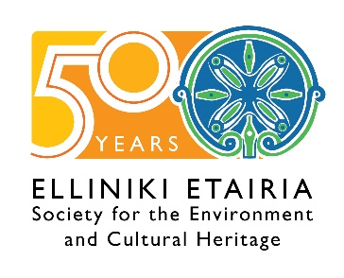
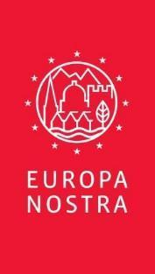

PRESS RELEASE

The 1st Costa Carras European Citizens Award
goes to the Romanian NGO “ARA”
for its exemplary work to safeguard the heritage of Roșia Montană

Brussels / The Hague / Athens, 21 April 2023

The Romanian NGO “ARA - Architecture. Restoration. Archeology” is awarded the very first Costa Carras European Citizens Award for the Safeguard of Endangered Cultural and Natural Heritage for its exemplary work mobilising citizens to promote and protect the outstanding heritage of Roșia Montană, located in Transylvania (Romania).

The Award was instituted earlier this year by EUROPA NOSTRA and ELLINIKI ETAIRIA - Society for the Environment and Cultural Heritage in memory of Costa Carras, an iconic champion of the protection of the environment and cultural heritage in Greece and in Europe. The founding partners of the Award are the A.G. Leventis Foundation, the Delphi Economic Forum and the European Investment Bank Institute.

The Award Ceremony will take place within the framework of the Delphi Economic Forum on 26 April in Delphi in the presence of H.E. The President of the Hellenic Republic Katerina Sakellaropoulou, an exceptional honour that demonstrates the highest recognition of the importance of civil society for democracy and for the safeguard of our cultural and natural heritage.

The Award’s Jury, who has unanimously and enthusiastically agreed on the first winner of the Costa Carras European Citizens Award for the Safeguard of Endangered Heritage, stated: “Ever since its establishment in 2006, the civil society organisation “ARA - Architecture. Restoration. Archaeology” from Romania has played a decisive role in coordinating the campaign to protect Roșia Montană with its endangered cultural heritage and landscape. With very modest financial means, but with huge mobilisation of dedicated volunteers - locally, nationally and internationally - they managed to convince the Romanian authorities to prioritise a heritage-led sustainable development and to successfully submit the application for the inclusion of Roșia Montană's historic mining landscape on UNESCO's World Heritage List. Their expert and courageous work is truly exemplary and gives inspiration to citizens across Europe to take strong ownership of their cultural and natural heritage and to engage in their safeguard”.

"By attributing the very first Costa Carras European Citizens Award to “ARA”, Europa Nostra wishes to reiterate its strong commitment to embracing and disseminating the values of sustainable development, which includes due respect for Europe's cultural heritage and landscape, and the vital role of citizens and local communities in deciding on the future of the heritage sites to which they are closely connected. It also underlines the vital link between the preservation of cultural heritage and the respect of the rule of law and the right to cultural heritage and the right to a healthy environment as fundamental human rights,” added the Jury.

Reacting to the announcement, “ARA” representatives commented: “It is a great privilege for us that the first award honouring the memory of Costa Carras, one of the most important champions of European heritage, goes to Roșia Montană, which he knew and appreciated, and for the conservation of which he fought with perseverance.
We believe that his voice in support of a sustainable development in Roșia Montană, as he raised it during the 7 Most Endangered site mission in 2014, is once again being heard today, through this award. We are glad that in recent years this scenario of heritage-led sustainable development, as Costa Carras himself imagined it back then, is beginning to take shape thanks to a mobilisation that has begun to grow beyond the efforts of our organisation, and that has found numerous allies, in the community, among specialists, and with the public authorities.
The award is thus the merit of a wider group than our association, “ARA”, wider even than the participants to our Adopt a House programme, to count local people, professionals, craftspeople, volunteers, students, and many remote supporters.”

The heritage importance of Roşia Montană

Situated in the western area of the Carpathian Mountains, the landscape of Roşia Montană has been gradually transformed by gold and silver mining, from prehistoric surface works to deep underground galleries, continued in medieval and modern times, up to the 1970’s. Along centuries, the settlers coming from various parts of Europe created communities of an interesting cultural diversity, to mention only the 5 denominations (Catholic, Orthodox, Greek Catholic, Unitarian and Calvinist), whose churches and houses are still witnesses of their way of life. All the surface features – paths, roads, reservoirs, water channels, stamping areas and Roşia Montană in itself – demonstrate a positive interaction between man and the environment, which has resulted in one of the most representative mining landscapes in Europe. The site as a whole and 50 of its components are listed as historic monuments and two geological formations as natural monuments. In 2021, the historic mining landscape of Roșia Montană was simultaneously inscribed on UNESCO’s World Heritage List and on the World Heritage List in Danger.

A major threat to the site and the vast surrounding area was the large-scale open-cast mining project. The destruction was averted thanks to the mass mobilization of citizens together with other national, European and international organisations and various local NGOs who advocated an alternative, sustainable, long-term development project based on the special characteristics of the area – the historic mining landscape with its outstanding cultural and natural heritage.

“ARA - Architecture. Restoration. Archaeology”

The organisation “ARA” was established in 2006, bringing together architects, restorers, archaeologists, art historians and engineers involved in the research of cultural heritage, who decided to extend their activity for the better knowledge, understanding and protection of cultural heritage.

ARA’s activity in Roșia Montană began in 2007, at a moment when a potential new mining project was looming large, the community was in the process of relocation, and the cultural heritage was under severe threat. The first actions were emergency rescue campaigns for two valuable and endangered community buildings, the Unitarian and Calvinist parish houses, developed with involvement of students from architecture schools and local people. This was the starting point for a continuous presence on the ground, with activities that merge research and documentation, emergency works, teaching and passing of skills and knowledge, conservation and restoration planning and works, communication and presentation of cultural heritage, and community building. Such actions have continued since, partly taking the form of Summer Schools for architecture students, Volunteer Camps and, from 2012, within the framework of the Adopt a House at Roșia Montană Programme.

The Adopt a House at Roșia Montană Programme, a cultural heritage and community rescue and protection programme, is making the connection between local owners of historic buildings, cultural heritage professionals, and donors or volunteers. All vernacular miners’ houses, churches and public buildings of Roșia Montană and the neighbouring villages are the focus of this programme, which is aimed to protect and promote the site’s valuable and spectacular historic environment, with a focus on built heritage, and ensure it is well taken care of and transmitted to future generations.

The programme entails collecting information, holding public presentations and consultations, coordinating surveys and projects, offering professional advice, ensuring planning and permitting for works, providing training, and promoting awareness of the value of preserving cultural heritage to society. The long-term goal of the programme is to effect change through the power of professional-coordinated, community-based and volunteer-supported historic preservation, restoring buildings and renewing the community of Roșia Montană and its surroundings.

The European Jury

The Award’s Jury, presided by Guy Clausse, Executive Vice-President of Europa Nostra (Luxembourg), is composed of independent experts in the fields of culture, heritage and communication from various European countries, namely Fani Mallouchou-Tufano, Professor - Conservation, Restoration and Management of Architectural Monuments and Sites, at Technical University of Crete (Greece), Paolo Vitti, Associate Professor, School of Architecture, University of Notre Dame (Italy), Simone Mizzi, Council Member of Europa Nostra (Malta), and Bruno Rossignol, Head of Programme for Climate and Heritage and Responsible for Communications - European Investment Bank Institute (France).

FOUNDING PARTNERS

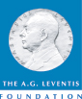
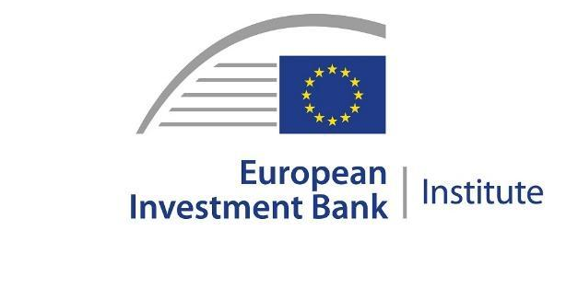

PRESS CONTACTS  EUROPA NOSTRA  Joana Pinheiro  Communications Coordinator  jp@europanostra.org, +31 6 34 36 59 85  ELLINIKI ETAIRIA - Society for the Environment  and Cultural Heritage  Katerina Stebili  sepi@ellinikietairia.gr, +30 210 32 25 245  “ARA - Architecture. Restoration. Archaeology”  Claudia Apostol  Volunteer and Comunication Coordinator for  the Adopt a House in Roșia Montană Programme, ARA  contact@adoptaocasa.ro, +40 731 383 333 | TO FIND OUT MORE  Photos  www.europanostra.org  www.ellet.gr  www.simpara.ro/GB
More information

The Costa Carras European Citizens Award for the Safeguard of Endangered Cultural and Natural Heritage

EUROPA NOSTRA and ELLINIKI ETAIRIA - Society for the Environment and Cultural Heritage launched in 2023 the Costa Carras European Citizens Award for the Safeguard of Endangered Cultural and Natural Heritage. For over 50 years, Costa Carras worked tirelessly in favour of Greece’s and Europe’s heritage to create a more sustainable, inclusive and beautiful world for future generations. The Costa Carras European Citizens Award celebrates the legacy of this iconic champion of Europe’s shared heritage and values, and inspires and encourages citizens to engage in defense of the values he stood for.
The Costa Carras European Citizens Award is presented annually to a European citizen, a group of individuals or a civil society organisation based in Europe for a successful and exemplary campaign to mobilise the public with the view of saving endangered heritage in their country or elsewhere in Europe. The winner of the Award receives a monetary prize of €10,000 and a certificate.

Costa Carras (1938-2022) was a visionary conservationist, an eminent historian and scholar as well as a distinguished businessman, a humanist and an idealist – a true Greek and a true European. He became Vice-President of Europa Nostra in 1976. Under his guidance, Europa Nostra built a truly pan-European heritage movement based on fundamental human rights and shared European values. Perhaps his most enduring legacy is the work of ELLINIKI ETAIRIA, which he founded with his wife Lydia Carras in 1972.

EUROPA NOSTRA

Europa Nostra is the European voice of civil society committed to safeguarding and promoting cultural and natural heritage. It is a pan-European federation of heritage NGOs, supported by a wide network of public bodies, private companies and individuals, covering over 40 countries. It is recognised as the largest and the most representative heritage network in Europe, maintaining close relations with the European Union, the Council of Europe, UNESCO and other international bodies. Founded in 1963, Europa Nostra celebrates its 60th anniversary this year.
Europa Nostra campaigns to save Europe’s endangered monuments, sites and landscapes, in particular through the 7 Most Endangered Programme. It celebrates excellence through the European Heritage Awards / Europa Nostra Awards. Europa Nostra actively contributes to the definition and implementation of European strategies and policies related to heritage, through a participatory dialogue with European Institutions and the coordination of the European Heritage Alliance.
Europa Nostra is among the official partners of the New European Bauhaus initiative developed by the European Commission, and is the Regional Co-Chair of the Climate Heritage Network for Europe and the Commonwealth of Independent States.
As of 1 May 2023, Europa Nostra will lead the European consortium selected by the European Commission to run the European Heritage Hub pilot project.

ELLINIKI ETAIRIA - Society for the Environment and Cultural Heritage

ELLINIKI ETAIRIA - Society for the Environment & Cultural Heritage (ELLET) – a non-profit, non-governmental association – has been fighting since 1972 for the protection of the environment and our cultural heritage. ELLET's action covers 3 main axes: a) Conservation/restoration projects of cultural heritage and natural environment; b) Institutional interventions to safeguard our common heritage (documented studies and proposals to policy-makers: for coastal & forest protection, tourism planning, carrying capacity, environmental tax reform and adaptation to climate change. Appeals and interventions in the public administration and other bodies for topical issues of protection of the natural and built environment. c) Awareness raising and education on natural and human-made environment issues. Environmental education, with programs for all levels.
ELLET is the official representative in Greece of Europa Nostra and cooperates with the Council of Europe, the European Union, UNESCO, the European Environmental Bureau and other bodies.
ELLET has received the European Citizen Award 2012 (European Parliament) and the Athens Academy Awards in 2002 "for 50 years of continuous and successful actions to protect our cultural heritage and the environment of Greece".

Attributed to citizens, group of citizens or organisations from one of the Member States of the Council of Europe (47 countries). The Award will not be given posthumously.

