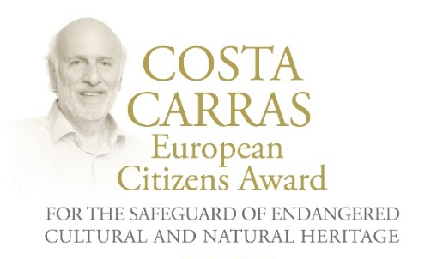
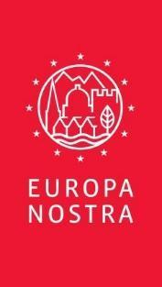
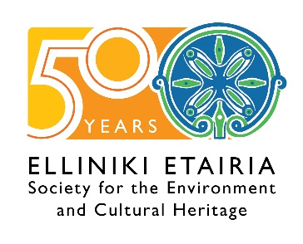

Apply for the Costa Carras European Citizens Award
for the Safeguard of Endangered Heritage 2024

14 December

EUROPA NOSTRA and ELLINIKI ETAIRIA - Society for the Environment and Cultural Heritage are proud to launch the Call for Entries for the second edition of the Costa Carras European Citizens Award for the Safeguard of Endangered Cultural and Natural Heritage. For over 50 years, Costa Carras worked tirelessly in favour of Greece’s and Europe’s heritage to create a more sustainable, inclusive and beautiful world for future generations. The Costa Carras European Citizens Award celebrates the legacy of this iconic champion of Europe’s shared heritage and encourages citizens to engage in defence of the values he stood for.

Launched in 2023, the Costa Carras European Citizens Award is presented annually to a European citizen, a group of individuals or a civil society organisation based in Europe for a successful and exemplary campaign to mobilise the public with the view of saving endangered heritage in their country or elsewhere in Europe. The winner of the Award receives a monetary prize of €10,000 and a certificate.

Applications for the second edition of the Costa Carras European Citizens Award for the Safeguard of Endangered Cultural and Natural Heritage can be submitted by 16 February 2024. This Application Form must be completed and sent via email to sepi@ellinikietairia.gr and/or info@europanostra.org.

The applications will be examined by a Jury composed of independent experts in the fields of culture, heritage and communication from various European countries.

The presentation Ceremony of the Costa Carras European Citizens Award will take place in mid-April 2024, in the framework of the Delphi Economic Forum 2024 in the ancient city of Delphi, Greece.

The Award was launched in 2023 by EUROPA NOSTRA and ELLINIKI ETAIRIA. The founding partners of the Award are the A.G. Leventis Foundation, the Delphi Economic Forum and the European Investment Bank Institute.

The Romanian NGO “ARA - Architecture. Restoration. Archeology” was awarded the very first Costa Carras European Citizens Award for the Safeguard of Endangered Cultural and Natural Heritage for its exemplary work mobilising citizens to promote and protect the outstanding heritage of Roșia Montană, located in Transylvania (Romania).

More information

COSTA CARRAS
Costa Carras (1938-2022) was a visionary conservationist, an eminent historian and scholar as well as a distinguished businessman, a humanist and an idealist – a true Greek and a true European. He became Vice-President of Europa Nostra in 1976. Under his guidance, Europa Nostra built a truly pan-European heritage movement based on fundamental human rights and shared European values. Perhaps his most enduring legacy is the work of ELLINIKI ETAIRIA, which he founded with his wife Lydia Carras in 1972.
Farewell to Costa Carras | Photos of Costa Carras

EUROPA NOSTRA
EUROPA NOSTRA is the European voice of civil society committed to safeguarding and promoting cultural and natural heritage. It is a pan-European federation of heritage NGOs, supported by a wide network of public bodies, private companies and individuals, covering over 40 countries. It is the largest and the most representative heritage network in Europe, maintaining close relations with the European Union, the Council of Europe, UNESCO and other international bodies. Founded in 1963, Europa Nostra celebrates its 60th anniversary this year.
Europa Nostra campaigns to save Europe’s endangered monuments, sites and landscapes, in particular through the 7 Most Endangered Programme. It celebrates and disseminates excellence through the European Heritage Awards / Europa Nostra Awards. Europa Nostra actively contributes to the definition and implementation of European strategies and policies related to heritage, through a participatory dialogue with European Institutions and the coordination of the European Heritage Alliance.
Since 1 May 2023, Europa Nostra has led the European consortium selected by the European Commission to run the European Heritage Hub pilot project. Europa Nostra is also an official partner of the New European Bauhaus initiative developed by the European Commission, and is the Regional Co-Chair for Europe of the Climate Heritage Network.

ELLINIKI ETAIRIA - Society for the Environment and Cultural Heritage
ELLINIKI ETAIRIA - Society for the Environment and Cultural Heritage (ELLET) – a non-profit, non-governmental association – has been fighting since 1972 for the protection of the environment and cultural heritage. ELLET's action covers 3 main axes: a) Conservation/restoration projects of cultural heritage and natural environment; b) Institutional interventions to safeguard our common heritage (documented studies and proposals to policy-makers: for coastal & forest protection, tourism planning, carrying capacity, environmental tax reform and adaptation to climate change. Appeals and interventions in the public administration and other bodies for topical issues of protection of the natural and built environment. c) Awareness raising and education on natural and human-made environment issues. Environmental education, with programs for all levels.
ELLET is the official representative in Greece of Europa Nostra and cooperates with the Council of Europe, the European Union, UNESCO, the European Environmental Bureau, the European Historic Houses association and other bodies.
ELLET has received the European Citizen Award 2012 (European Parliament) and the Athens Academy Awards in 2002 "for 50 years of continuous and successful actions to protect our cultural heritage and the environment of Greece ".
CONTACTS  EUROPA NOSTRA  Joana Pinheiro,  jp@europanostra.org, +31 6 34 36 59 85  ELLINIKI ETAIRIA  Katerina Stebili  sepi@ellinikietairia.gr, +30 210 32 25 245 | TO FIND OUT MORE  www.europanostra.org  www.ellet.gr

Attributed to citizens, group of citizens or organisations from one of the Member States of the Council of Europe (47 countries). The Award will not be given posthumously.

