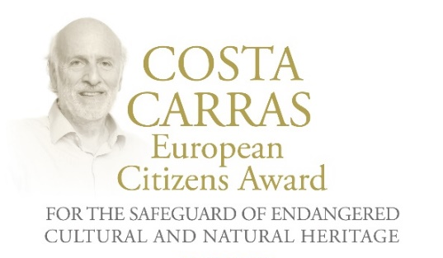
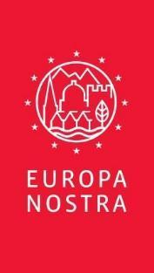
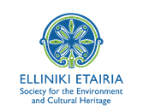

PRESS RELEASE

Winners of the Costa Carras European Citizens Awards
for the Safeguard of Endangered Heritage 2024 announced:

Stéphane Bern, renowned French journalist and heritage champion,
wins the Golden Award

Silver Award goes jointly to
the Greek NGO Archilochos - Cultural Association of Paros, and
the Turkish NGO Haydarpaşa Solidarity for Society, City and Environment

Brussels / The Hague / Athens, 21 March 2024

The 2024 winners of the Costa Carras European Citizens Awards for the Safeguard of Endangered Heritage were announced today. Stéphane Bern, a renowned French-Luxembourgish journalist, radio host and television presenter, and a prominent heritage advocate, has won the Golden Award for his exemplary work in raising awareness of the need to save heritage at risk in France and in the rest of Europe.

The Jury granted the newly established Silver Award jointly to two NGOs, Archilochos - Cultural Association of Paros (Greece) and Haydarpaşa Solidarity for Society, City and Environment (Türkiye), for successfully organising local citizens movements to promote and preserve their cultural and natural heritage.

The Award Ceremony will take place on 10 April, within the framework of the Delphi Economic Forum. The Ceremony will be held in the presence of H.E. the President of the Hellenic Republic, Katerina Sakellaropoulou, and H.E. the President of the Republic of Slovenia, Nataša Pirc Musar.

The Costa Carras European Citizens Awards for the Safeguard of Endangered Heritage were established in 2023 by EUROPA NOSTRA and ELLINIKI ETAIRIA - Society for the Environment and Cultural Heritage in memory of Costa Carras, an iconic champion of the protection of the environment and cultural heritage in Greece and Europe. The founding partners of the Awards are the A.G. Leventis Foundation, the Delphi Economic Forum and the European Investment Bank Institute. The Golden Award and the Silver Award are generously financed by the A.G. Leventis Foundation.

The response to the Call for Entries 2024 was impressive. 22 applications were received from Belgium, Cyprus, France, Georgia, Greece, Italy, Norway, Serbia, Spain, Türkiye and Ukraine. Based on this response, the Silver Award has been established.

Golden Award for Stéphane Bern (France/Luxembourg)

Reacting to the announcement, Stéphane Bern commented: “For all heritage defenders, the name of Costa Carras evokes fifty years of tireless fighting in favour of historical heritage and its environmental setting in Europe. Vice-President of Europa Nostra and founder of ELLINIKI ETAIRIA, Costa Carras showed us how to protect and safeguard heritage which cannot continue to exist without the support of people. As a lover of Greece, where I have resided occasionally for twenty-four years, as an ardent defender of French heritage and as a European, I am very honoured to be awarded the Costa Carras European Citizens Award. It is a real encouragement to continue the action that I have been carrying out for seven years, at the request of the President of the French Republic and with the assistance of the Fondation du Patrimoine, to safeguard each year the nearly 120 monuments in danger that are reported by the public, who then participate in their restoration thanks to the Heritage Lottery that I was able to initiate with the Française des Jeux. To date, we have been able to select 875 monuments which are saved or are in the process of being saved. I therefore dedicate this Costa Carras Award to all of my compatriots who have realised that we are all collectively and individually custodians of historical heritage.”

The Award’s Jury stated: “Stéphane Bern is a highly worthy laureate of the Costa Carras European Award owing to his steadfast dedication to conserving and championing Europe’s cultural heritage. Known as "Mr. Heritage" in France, Bern's influential television programmes have spurred significant actions to protect heritage in his country. ‘Mission Bern’, a special mission entrusted to Stéphane Bern (acting in a purely voluntary capacity) and initiated by the Fondation du Patrimoine and supported by the Ministry of Culture, also included the creation of the innovative Heritage Lottery (Loto du Patrimoine), with the Française des Jeux which has helped direct funding and much-needed awareness to hundreds of heritage sites in France. Yet, Bern's efforts extend beyond France, as he has raised awareness on a European and global scale through his many television programmes dedicated to European heritage. His tireless endeavours, culminating in the successful restoration of the former Royal and Military College of Thiron-Gardais, epitomise his profound impact on conserving endangered heritage.”

Stéphane Bern's mission is characterised by his multidisciplinary efforts to raise awareness of endangered heritage across Europe. Commencing his career with television programmes focused on French heritage, he has since broadened his vision to encompass the preservation of European heritage through books and radio podcasts. His unwavering commitment has led to the establishment of the Stéphane Bern Foundation for History and Heritage, affiliated with the Institut de France. Additionally, in 2022, Bern created the Association for Former Royal and Military Academies to facilitate academic exchanges between different campuses, rejuvenating their heritage and promoting their history.

The Heritage Lottery was launched in 2017, after the President of the French Republic Emmanuel Macron entrusted Stéphane Bern with a mission - implemented on a voluntary basis - to identify endangered heritage and seek new sources of funding to restore it. Thanks in particular to the attachment of the French people to their heritage, nearly 230 million euros have been allocated to support the restoration work on all the sites selected since the beginning. More than 850 sites have been assisted with their restoration work. Today, more than 500 sites have already been saved or are about to be saved.

Bern's mission transcends borders, as evidenced by his dedication to promoting European heritage through television programmes such as “Bons baisers d’Europe” and “Viennese Getaway”. His advocacy has garnered international attention, inspiring other European countries to contemplate adopting similar strategies for the safeguard of heritage at risk.

Stéphane Bern’s efforts have garnered recognition on both national and European platforms. He has been honoured with numerous awards, including the European Heritage Award / Europa Nostra Award in 2018, in acknowledgement of his successful endeavours to safeguard French heritage and save endangered historical monuments and sites.

Silver Award for two outstanding NGOs from Greece and Türkiye

Archilochos - Cultural Association of Paros (Greece)

Founded in 1976, Archilochos - Cultural Association of Paros has played a pivotal role in promoting local culture and conserving the unique environment of the island. Through initiatives such as the “Citizens' Movement”, it has actively involved the community in tackling pressing issues, ranging from healthcare improvements to environmental preservation. Despite undergoing transformations over time, Archilochos remains a significant force in shaping the cultural and environmental landscape of Paros and the Cyclades.

Archilochos emerged onto the European stage in the aftermath of the summer of 2023, when Paros citizens garnered support from various organisations and established the “Citizens Movement” to safeguard the environmental heritage of the Cyclades coastline and reclaim free beaches for the inhabitants (also called by the media the “Beach towel Movement”) . The movement gained traction, both nationally and internationally, inspiring similar initiatives in other regions. Archilochos has been proactive in advocating for the preservation of natural and cultural landscapes through petitions, protests, and communication campaigns. This activism led to public recognition of the issue by the Minister of the Environment and the Supreme Court (Areios Pagos) in Greece, along with the mobilisation of relevant authorities, including the Prosecutor of the Appeals Court of Syros. Demonstrating its ongoing adaptability and dedication to preserving the Cycladic character of Paros island, Archilochos continues to foster democratic decision-making and community participation.

The Award’s Jury stated: “Archilochos is an outstanding citizens’ movement and its activities, on the island of Paros and on a wider national scale, impressively reflect how citizens can raise their voice for the safeguarding of the environmental heritage of the Cyclades coastline.”

Archilochos - Cultural Association of Paros commented: “It is a great honour to receive the Costa Carras Silver Award. This act validates the efforts of all those citizens who fought last summer creating a pan-European movement for the protection of our coasts, public space and environment. This award gives us the strength and courage to continue our efforts to protect the threatened natural and cultural heritage of our land.”

Haydarpaşa Solidarity for Society, City and Environment (Türkiye)

Haydarpaşa Solidarity for Society, City and Environment, founded in 2005, is a committed advocate for the preservation and utilisation of the historic Haydarpaşa Train Station in Istanbul. Over the years, the organisation has spearheaded a multifaceted campaign, involving legal challenges and grassroots activism, alongside partners such as the United Transport Employees Union and the TMMOB Chamber of Architects. The organisation’s mission extends beyond Türkiye, resonating as a unique example of urban social movements globally. By organising both the city and labour movements, the Haydarpaşa has established a pioneering approach to addressing contemporary urban challenges and preserving cultural heritage.

Situated in Kadıköy, on the Anatolian Side of Istanbul, the Haydarpaşa Train Station is not only a transportation hub but also an integral part of the city's cultural and social fabric. Built in 1908 by the German architects Otto Riter and Helmut Cuno, its Neo-Renaissance exterior and Baroque and Gothic interior elements reflect its rich architectural heritage. Despite facing threats from urban transformation projects, including proposals for conversion into a hotel or museum, the organisation’s tireless efforts have successfully defended the station's role as a public space and transportation hub. Through a 19-year struggle marked by protests, occupations, and cultural events, Haydarpaşa has not only safeguarded the station but also fostered dialogue and community cohesion, setting a powerful example of grassroots activism and the “right to the city” movement globally.

The Award’s Jury stated: “Haydarpaşa Solidarity for Society, City and Environment has now remained engaged for almost 20 years, defending the iconic architectural heritage of this railway station. As a rich and diverse activity, involving many important partners, this has been and is exemplary for a pro-active urban social movement in Türkiye and beyond.”

Haydarpaşa Solidarity for Society, City and Environment commented: “Since 2005, Haydarpaşa Train Station has been facing the threat of losing its historical and industrial function under the name of urban transformation. In response, Haydarpaşa Solidarity is waging a legal and street struggle to ensure that its original architectural structure and its connection with trains are preserved for future generations. Being awarded the Costa Carras Silver Award 2024 is an honour that will strengthen our ongoing struggle. ”

The European Jury

The Award’s Jury, chaired by Guy Clausse, Executive Vice-President of Europa Nostra (Luxembourg), is composed of independent experts in the fields of culture, heritage and communication from various European countries. They are: Ştefan Bâlici, Director General of the National Institute of Heritage (Romania); Lydia Carras, Founder and Vice-President of Elliniki Etairia (Greece); Fani Mallouchou-Tufano, Professor of Conservation, Restoration and Management of Architectural Monuments and Sites at Technical University of Crete and Deputy President of the Committee for the Preservation of the Acropolis Monuments (ESMA) (Greece); Sneška Quaedvlieg-Mihailović, Secretary General of Europa Nostra (Netherlands/Serbia); Bruno Rossignol, Head of Programme for Climate and Heritage at the European Investment Bank Institute (France); and Paolo Vitti, Associate Professor, School of Architecture, University of Notre Dame (Italy).

FOUNDING PARTNERS OF THE COSTA CARRAS EUROPEAN CITIZENS AWARDS

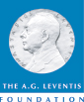
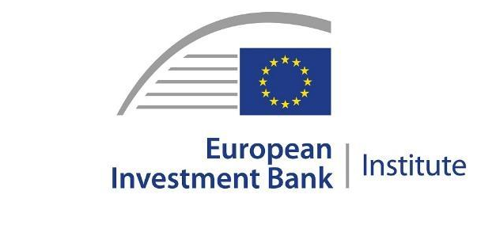

PRESS CONTACTS  EUROPA NOSTRA  Joana Pinheiro  Communications Coordinator  jp@europanostra.org, +31 6 34 36 59 85  ELLINIKI ETAIRIA - Society for the Environment  and Cultural Heritage  Katerina Stebili  sepi@ellinikietairia.gr, +30 210 32 25 245 | TO FIND OUT MORE  Photos  www.europanostra.org  www.ellet.gr

More information

Costa Carras European Citizens Awards for the Safeguard of Endangered Cultural and Natural Heritage
EUROPA NOSTRA and ELLINIKI ETAIRIA - Society for the Environment and Cultural Heritage launched in 2023 the Costa Carras European Citizens Awards for the Safeguard of Endangered Cultural and Natural Heritage.
For over 50 years, Costa Carras worked tirelessly in favour of Greece’s and Europe’s heritage to create a more sustainable, inclusive and beautiful world for future generations. The Costa Carras European Citizens Awards celebrate the legacy of this iconic champion of Europe’s shared heritage and values, and inspire and encourage citizens to engage in the defence of the values he stood for.
The Costa Carras European Citizens Awards are presented annually to a European citizen, a group of individuals or a civil society organisation based in Europe for a successful and exemplary campaign to mobilise the public to save endangered heritage in their country or elsewhere in Europe. The winner of the Golden Award receives a monetary prize of €10,000 and a certificate. The winner of the Silver Award receives a monetary prize of €5,000 and a certificate.
The founding partners of the Awards are the A.G. Leventis Foundation, the Delphi Economic Forum and the European Investment Bank Institute.

EUROPA NOSTRA
Europa Nostra is the European voice of civil society committed to safeguarding and promoting cultural and natural heritage. It is a pan-European federation of heritage NGOs, supported by a wide network of public bodies, private companies and individuals, covering over 40 countries. It is the largest and the most representative heritage network in Europe, maintaining close relations with the European Union, the Council of Europe, UNESCO and other international bodies. Founded in 1963, Europa Nostra celebrated its 60th anniversary last year.
Europa Nostra campaigns to save Europe’s endangered monuments, sites and landscapes, in particular through the 7 Most Endangered Programme. It celebrates and disseminates excellence through the European Heritage Awards / Europa Nostra Awards. Europa Nostra actively contributes to the definition and implementation of European strategies and policies related to heritage, through a participatory dialogue with European Institutions and the coordination of the European Heritage Alliance.
Europa Nostra has led the European consortium selected by the European Commission to run the European Heritage Hub pilot project (2023-2025). It is also an official partner of the New European Bauhaus initiative developed by the European Commission, and is a leading European member and supporter of the Climate Heritage Network.

ELLINIKI ETAIRIA - Society for the Environment and Cultural Heritage
ELLINIKI ETAIRIA - Society for the Environment & Cultural Heritage – a non-profit, non-governmental association – has been fighting since 1972 for the protection of the environment and our cultural heritage. ELLET's action covers 3 main axes: a) Conservation/restoration projects of cultural heritage and the natural environment; b) Institutional interventions to safeguard our common heritage (documented studies and proposals to policy-makers: for coastal & forest protection, tourism planning, carrying capacity, environmental tax reform and adaptation to climate change. Appeals and interventions in the public administration and other bodies for topical issues of protection of the natural and built environment.); c) Awareness raising and education on natural and human-made environmental issues. Environmental education, with programs for all levels.
ELLET is the official representative in Greece of Europa Nostra and cooperates with the Council of Europe, the European Union, UNESCO, the European Environmental Bureau and other bodies.
ELLET has received the European Citizen Award 2012 (European Parliament) and the Athens Academy Awards in 2002 "for 50 years of continuous and successful actions to protect our cultural heritage and the environment of Greece".

Attributed to citizens, group of citizens or organisations from one of the Member States of the Council of Europe (47 countries). The Award will not be given posthumously.

