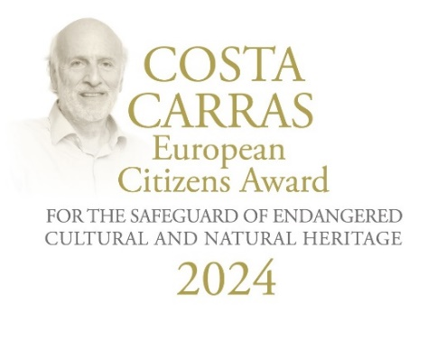
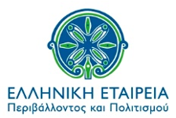
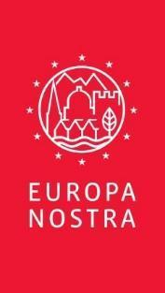

PRESS RELEASE
Costa Carras European Citizens Awards 2024 presented to the winners in Delphi in the presence of the President of the Hellenic Republic

Delphi, 15 April 2024

The presentation ceremony of the Costa Carras European Citizens Awards for the Safeguard of Endangered Cultural and Natural Heritage 2024 took place on 10 April, in Delphi, in the presence of H.E. the President of the Hellenic Republic, Ms Katerina Sakellaropoulou. Over 150 participants honoured the winner of the Golden Award, Stéphane Bern, and the joint winners of the Silver Award, the Greek NGO Archilochos - Cultural Association of Paros and the Turkish NGO Haydarpaşa Solidarity for Society, City and Environment. The award ceremony was organised within the framework of the Delphi Economic Forum 2024 and moderated by Sneška Quaedvlieg Mihailović, Secretary General of Europa Nostra.

Stéphane Bern, a renowned French-Luxembourgish journalist, radio host and television presenter, and a prominent heritage advocate, received the Golden Award for his exemplary work in raising awareness of the need to save heritage at risk in France and in the rest of Europe. The Jury granted the newly established Silver Award jointly to two NGOs, Archilochos - Cultural Association of Paros (Greece) and Haydarpaşa Solidarity for Society, City and Environment (Türkiye), for successfully organising local citizens movements to promote and preserve their endangered cultural and natural heritage.

The Award was instituted in 2023 by Europa Nostra and ELLINIKI ETAIRIA - Society for the Environment and Cultural Heritage (ELLET) in memory of Costa Carras, an iconic figure for the protection of the environment and cultural heritage in Greece as well as in Europe and beyond. The founding partners are the A.G. Leventis Foundation, the Delphi Economic Forum and the European Investment Bank Institute.

Messages from the winners of the Awards

In his acceptance speech, Stéphane Bern said: “The name of Costas Carras stands for fifty years of tireless fighting in favour of cultural heritage and its surrounding environment in Europe. Costa Carras showed us how to protect and safeguard heritage which cannot continue to exist without the support of people. For all lovers and defenders of Europe’s cultural and natural heritage, Costa Carras is a model and an example. As a true humanist, he had a vision and passion, not only for Greek heritage but also for the heritage of Europe as a whole.”

Stéphane Bern dedicated his award to all his compatriots who are custodians of cultural heritage: “This award serves as great encouragement to continue the voluntary action that I have been carrying out for seven years, at the request of the President of the French Republic, Emmanuel Macron, and with the assistance of the French NGO – la Fondation du Patrimoine, to safeguard each year the nearly 120 monuments in danger that are reported by the public. It is also the public that participates in their restoration thanks to the National Heritage Lottery, inspired by the British model of the Heritage Lottery Fund which I was able to initiate with the Française des Jeux. I keep repeating in every way possible, particularly in the media, that heritage is not just a matter for the State. We are all its guardians, its custodians, individually and collectively. What I am conveying to local elected officials – which I have also become three weeks ago – is that heritage is not a luxury, it is a necessity. It is not a cost; it is an investment. Heritage is a vector of identity, it is a factor for integration and social cohesion, it is a link between generations, it is also a source of sustainable economic activity in many villages where it is sometimes the only touristic asset. Finally, it is for citizens their first contact with art, history and culture.” Stephane Bern is planning to invest the monetary award to support the education of younger generations on cultural heritage, with a special focus on school children.

On behalf of Haydarpaşa Solidarity for Society, City and Environment, Tugay Kartal said: “I would like to greet those who lost their lives during the GEZİ and our friends who are still in prison despite their acquittals and the European Court of Human Rights decisions… We feel encouraged to continue our 639th Sunday vigil with this award and support. With this award, the precious memory of Mr. Costa Carras will live on together with us on the stairs of Haydarpaşa Station. Haydarpaşa is a station, it will remain as a station!”

During his acceptance speech, Stavros Stellas, representative of Archilochos - Cultural Association of Paros, stated: “I accept this award in the name of all those, particularly the people of Paros but also visitors, who dedicated their time and effort last summer, even during their holidays, to demand the protection of the public nature of the coasts of our island, as stipulated by law.” He also highlighted: “I would also like to mention that these results, at a local level, would not have been achieved if public officials such as the prosecutor and the Paros Police Department did not do exactly what they should have done. That is to say, they did their job very well. We thank them publicly.”

Congratulatory messages

During the ceremony, Ms. Alexandra Sdoukou, Deputy Minister of Environment and Energy, expressed her gratitude, remarking: "It gives me great pleasure to be here today, representing the Greek Prime Minister, Mr. Kyriakos Mitsotakis, at the award ceremony of the Costa Carras European Citizens' Awards, in memory of Costa Carras and his tireless zeal for the protection of the natural and cultural heritage of the country." She commended the relentless efforts of ELLET over the past 50 years in preserving Greece's natural and cultural heritage, particularly in Delphi. Ms. Sdoukou's speech underscored the urgency of addressing climate change, emphasising the need for a protective shield not only for the natural environment but also for cultural heritage monuments, landmarks, and intangible heritage.

“In a joint effort to preserve our heritage, Greece and France share the same vision. The contributions of Stéphane Bern defy summarisation, as he has seamlessly bridged the past with the present. His efforts have integrated heritage into our everyday lives, enriching our cultural landscape,” said François De Ricolfis, Head of Economics at the Embassy of France, speaking on behalf of Laurence Auer, Ambassador of France to Greece. “You have created a link between the past and the present, you have shown that heritage belongs to all of us and not to a limited happy few, you have given visibility to forgotten places and stories, and you helped to make our heritage an integral part of our everyday existence, and not only a place to visit one in a lifetime. This is your wonderful gift to all of us,” he said while congratulating Stéphane Bern.

Words from the partners of the Awards

Stressing the deep gratitude for the presence of the President of the Hellenic Republic at the award ceremony, Sneška Quaedvlieg-Mihailović, Secretary General of Europa Nostra, recalled: “Greece is the birthplace of democracy, and continues today to be the beacon of democracy in Europe and the world. Together we must join forces to protect democracy, which is today the most endangered cultural heritage, based on respect of human rights and the rule of law. In ancient times, pilgrims gathered in the Delphi sanctuary to pray for a better future. Today, we are gathered in Delphi to join our voices and forces for a better tomorrow.”

Lydia Carras, Founder and Vice-President of Elliniki Etairia, during her speech, stated: “For the Golden Award, the Jury chose Stéphane Bern, who through his TV programmes stands out as a media champion for Heritage in France, but also in Europe as a whole. The Jury’s Silver Award is presented jointly to Turkey and Greece. The story of Haydarpaşa, where citizens’ are campaigning for 10 consecutive years to save this iconic building, is really impressive and moving. The mobilisation of Archilochos in Paros is also an amazing story of citizens’ action. All these awards are for citizens. Costa Carras believed in the vital role of citizens to protect Heritage and Democracy. We live once more in a world devastated by wars and conflict, some very close to us. Democracies once more are in danger in many parts of our planet. The citizens who won these awards should give us hope, that we should not despair, that good can prevail.”

“Costa Carras is missed at the Delphi Economic Forum, he is missed by the great contemporary thinkers and he is missed by all those who fight for the protection of cultural and natural heritage”, said Simeon Tsomokos, Founder and President of the Delphi Economic Forum. He also warmly congratulated the Golden Award laureate, Stéphane Bern, and extended to him a warm invitation to be one of the key speakers at the next edition of the Delphi Economic Forum.

In a video message, Anastasios P. Leventis, President of the A.G. Leventis Foundation, extended congratulations on the decision to bestow the award, highlighting the enduring vision of Costa Carras and recognising Stéphane Bern’s work as a “steadfast advocate for European heritage, seamlessly blending his efforts with a vision that transcends borders”. He also congratulated Archilochos and Haydarpaşa Solidarity for Society, City and Environment for their success in promoting their work at both local and European levels, and praised Europa Nostra and ELLET for their continued dedication for heritage.

Kyriacos Kakouris, Vice-President of the European Investment Bank, said: “These awards illustrate the importance of the role civil society plays in raising awareness and in protecting cultural heritage at risk. The awards today tell us a beautiful story. A story of engagement, of commitment and of success. Congratulations to the winners for doing so much to raise awareness and to save heritage in danger. The EIB, through its Institute, is proud to be on your side.”

Stathis Potamitis, President of ELLET, emphasised: “After closely listening to the laureates, I would summarise their actions as marked by the assumption of personal responsibility, respect and practical love for our heritage, natural and cultural.”

The European Jury

The Award’s Jury, chaired by Guy Clausse, Executive Vice-President of Europa Nostra (Luxembourg), is composed of independent experts in the fields of culture, heritage and communication from various European countries. They are: Ştefan Bâlici, Director General of the National Institute of Heritage (Romania); Lydia Carras, Founder and Vice-President of Elliniki Etairia (Greece); Fani Mallouchou-Tufano, Professor of Conservation, Restoration and Management of Architectural Monuments and Sites at Technical University of Crete and Deputy President of the Committee for the Preservation of the Acropolis Monuments (ESMA) (Greece); Sneška Quaedvlieg-Mihailović, Secretary General of Europa Nostra (Netherlands/Serbia); Bruno Rossignol, Head of Programme for Climate and Heritage at the European Investment Bank Institute (France); and Paolo Vitti, Associate Professor, School of Architecture, University of Notre Dame (Italy).

FOUNDING PARTNERS

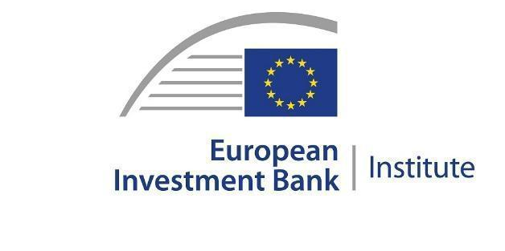
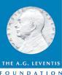

PRESS CONTACTS  EUROPA NOSTRA  Joana Pinheiro  Communications Coordinator  jp@europanostra.org, +31 6 34 36 59 85  ELLINIKI ETAIRIA - Society for the Environment  and Cultural Heritage  Katerina Stebili  sepi@ellinikietairia.gr, +30 210 32 25 245 | TO FIND OUT MORE  Photos  www.europanostra.org  www.ellet.gr
More information

Costa Carras European Citizens Awards for the Safeguard of Endangered Cultural and Natural Heritage
EUROPA NOSTRA and ELLINIKI ETAIRIA - Society for the Environment and Cultural Heritage launched in 2023 the Costa Carras European Citizens Awards for the Safeguard of Endangered Cultural and Natural Heritage.
For over 50 years, Costa Carras worked tirelessly in favour of Greece’s and Europe’s heritage to create a more sustainable, inclusive and beautiful world for future generations. The Costa Carras European Citizens Awards celebrate the legacy of this iconic champion of Europe’s shared heritage and values, and inspire and encourage citizens to engage in the defence of the values he stood for.
The Costa Carras European Citizens Awards are presented annually to a European citizen, a group of individuals or a civil society organisation based in Europe for a successful and exemplary campaign to mobilise the public to save endangered heritage in their country or elsewhere in Europe. The winner of the Golden Award receives a monetary prize of €10,000 and a certificate. The winner of the Silver Award receives a monetary prize of €5,000 and a certificate.
The founding partners of the Awards are the A.G. Leventis Foundation, the Delphi Economic Forum and the European Investment Bank Institute.

EUROPA NOSTRA
Europa Nostra is the European voice of civil society committed to safeguarding and promoting cultural and natural heritage. It is a pan-European federation of heritage NGOs, supported by a wide network of public bodies, private companies and individuals, covering over 40 countries. It is the largest and the most representative heritage network in Europe, maintaining close relations with the European Union, the Council of Europe, UNESCO and other international bodies. Founded in 1963, Europa Nostra celebrated its 60th anniversary last year.
Europa Nostra campaigns to save Europe’s endangered monuments, sites and landscapes, in particular through the 7 Most Endangered Programme. It celebrates and disseminates excellence through the European Heritage Awards / Europa Nostra Awards. Europa Nostra actively contributes to the definition and implementation of European strategies and policies related to heritage, through a participatory dialogue with European Institutions and the coordination of the European Heritage Alliance.
Europa Nostra has led the European consortium selected by the European Commission to run the European Heritage Hub pilot project (2023-2025). It is also an official partner of the New European Bauhaus initiative developed by the European Commission, and is a leading European member and supporter of the Climate Heritage Network.

ELLINIKI ETAIRIA - Society for the Environment and Cultural Heritage
ELLINIKI ETAIRIA - Society for the Environment & Cultural Heritage – a non-profit, non-governmental association – has been fighting since 1972 for the protection of the environment and our cultural heritage. ELLET's action covers 3 main axes: a) Conservation/restoration projects of cultural heritage and the natural environment; b) Institutional interventions to safeguard our common heritage (documented studies and proposals to policy-makers: for coastal & forest protection, tourism planning, carrying capacity, environmental tax reform and adaptation to climate change. Appeals and interventions in the public administration and other bodies for topical issues of protection of the natural and built environment.); c) Awareness raising and education on natural and human-made environmental issues. Environmental education, with programs for all levels.
ELLET is the official representative in Greece of Europa Nostra and cooperates with the Council of Europe, the European Union, UNESCO, the European Environmental Bureau and other bodies.
ELLET has received the European Citizen Award 2012 (European Parliament) and the Athens Academy Awards in 2002 "for 50 years of continuous and successful actions to protect our cultural heritage and the environment of Greece".

Attributed to citizens, group of citizens or organisations from one of the Member States of the Council of Europe (47 countries). The Award will not be given posthumously.

